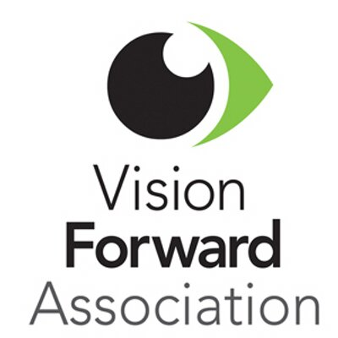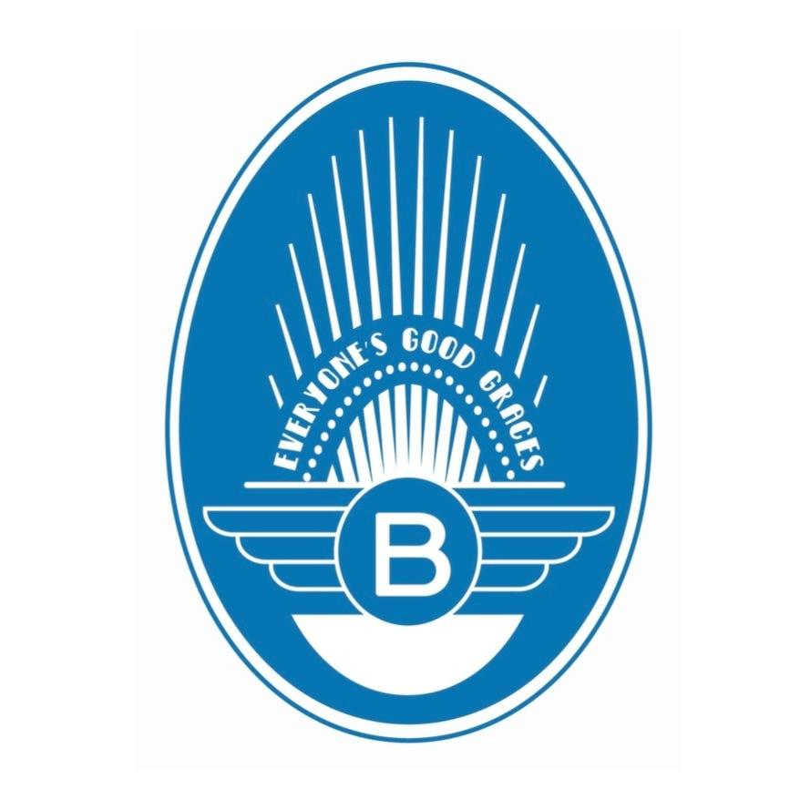

**Vision Forward is the Blue’s Egg**

**Egg Plate Charity of August!**

**About Vision Forward:**

Vision Forward provides a continuum of services, from birth through adulthood, to people with visual impairments, helping them achieve important developmental milestones as well as educational, personal and professional goals.

**www.vision-forward.org**

$**1 of every Egg Plate**

sold during the month of August will be donated to Vision Forward!