Mary’s 2020 Gift Guide

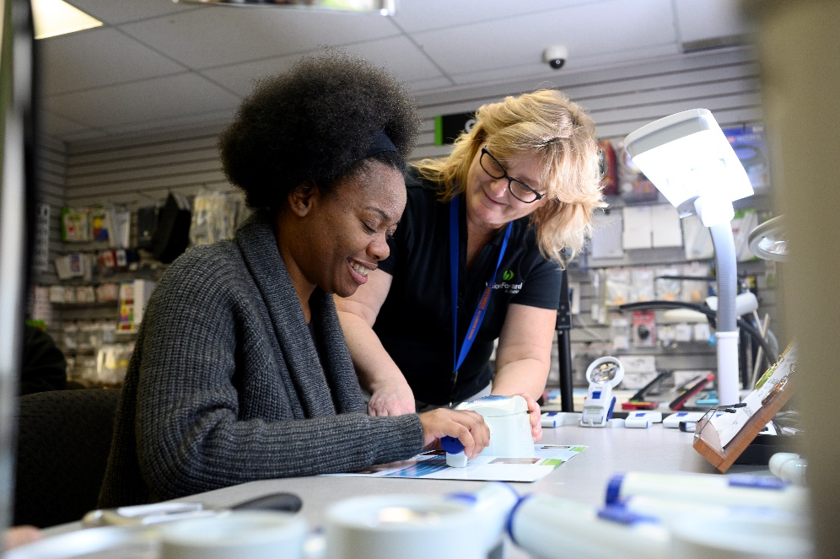
“I really enjoy meeting the Vision Forward Store customers. Knowing how challenging it can be to find the “perfect” gift, I put together some ideas for gift buying this holiday season. We have a new Store catalog with even more options. Feel free to call me in the Store at (414) 615-0111 or send me email at store@vision-forward.org. Mention this guide when you place your order, and I’ll include a free Vision Forward signature guide.”
- Mary, Vision Forward Store Coordinator

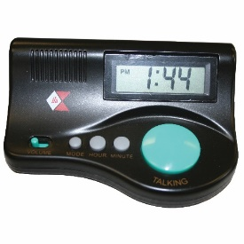
Big Green Button Easy Talk Clock
This small, talking desktop clock with LED screen features a contrasting large button on the front. Simply push it to hear the time spoken! Simple controls set the time and alarm and change the volume. Uses two AA batteries (not included).
T835888: $12.00

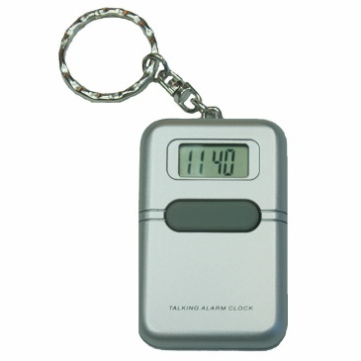
Talking Easy Use Alarm Clock Keychain
Simply press the large button on the front of this pocket-sized clock to hear the time in a clear, loud voice. Also includes an easy to use alarm feature.
T6685 (English): $12.50
T6685S (Spanish): $12.50
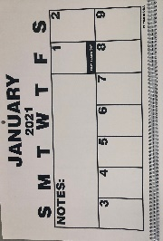

2021 Large Print Wall Calendar
Bold print and large spaces to write in make this 18-month large print wall calendar an important tool in helping to stay organized.
LWALLCAL21: $13.50

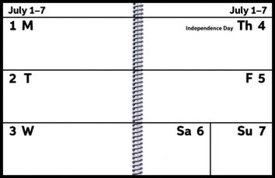
2021 Large Print Planner/Calendar
This 8½” x 11” spiral-bound planner features a sturdy, laminated cover with large, bold print and ample space for writing notes and jotting down appointments.
LEZPLAN21: $23.50

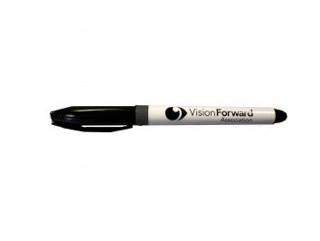
Vision Forward Bold Pen
Look no further for a bold writing tool that doesn’t bleed through paper and smear like other pens and markers.
L2020: $1.50

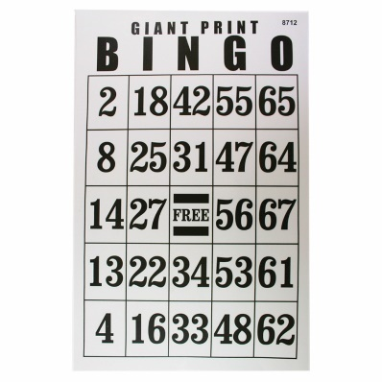
Jumbo Laminated Bingo Card
This 11″ X 17″ laminated bingo card has large,
bold black numbers on a white background.
Randomly selected 2” numbers are placed in
the five columns.
G4055352: $4.75

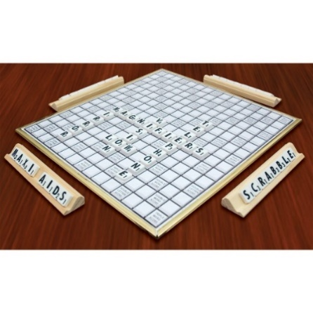
Deluxe Large Print Low Vision Scrabble
Enjoy the classic game of Scrabble with
high contrast, large black ½” letters on a white background. Features a rotating board.
G29444: $45.00
G29444T (low vision tiles only): $14.50
G29454T (braille tiles only): $29.50

Tomato Slicer and Knife Aid
Safely cut tomatoes, onions and more by
placing the vegetable into the slicer. Cut
between the grooves for a perfect slice every
time. Use only with a non-serrated knife; a 8¼”
knife is included. BPA free and dishwasher
safe.
H553145: $10.50

Food Pod Silicone Cooking Bag
Easily boil, blanch, steam and drain with this silicone basket. A clip holds the handle out of the hot water. Simply pull the pod out of the hot water and the water drains away, leaving the food in the basket. The Food Pod measures 6″ round x 5″ tall.
H421175: $15.75
Mobility Mittens
These one-size-fits-most mittens have a specially-designed opening where a white cane can fit through. Contact us to make your selection from a variety of patterns.
XMMITTS: $38.00

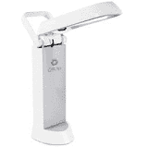
Rechargeable Task Lamp
Use the built-in handle to take this portable 13 watt task lamp from room to room with its unique fold-up design. The rechargeable battery provides up to three hours of use. The low heat bulb provides low glare illumination to help prevent eye strain.
E571PN3: $76.50

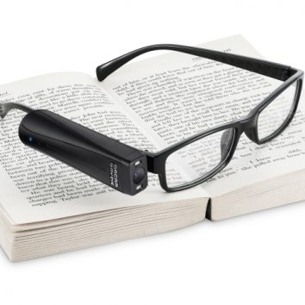
Orcam MyEye 2.0 Advanced Reading Assistant
Orcam MyEye 2.0 is a digital assistant that uses artificial intelligence to read printed text, recognize faces, identify products, identify color and recognize money. Orcam is easy to use, portable and discreet.
YORCAM2: $4,250.00

Explore 8
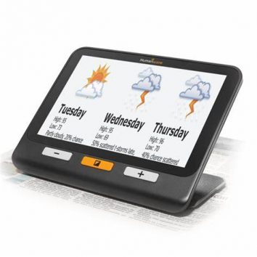
The eight-inch screen on this electronic magnifier provides up to 30X magnification with a sharp HD image. Use at home or take on the road with battery life of 4.5 hours. The Explore 8 has twin Ultra HD cameras for desktop or distance viewing and can be connected easily to a large screen TV.
YEXPLORE 8: $1,099.00

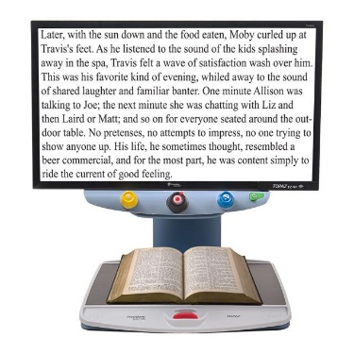
24” Topaz EZ HD
The Topaz EZ HD is a desktop electronic magnifier that provides brilliant magnified high-definition images with easy-to-use controls. Use to magnify reading material, photos and more!
YTOPAZEZ24HD: $2,795.00
On sale for $2,545.00 through 12/31/2020!

Check out our InFocus resources at
www.vision-forward.org/infocus for product highlights, instructional videos and helpful articles presented by Cory Ballard, Vision Forward Director of Technology and Luke Scriven, Vision Forward Assistive Technology Specialist. Cory and Luke are nationally recognized speakers and trainers in the use of the latest cutting-edge technology for people with vision loss.

