
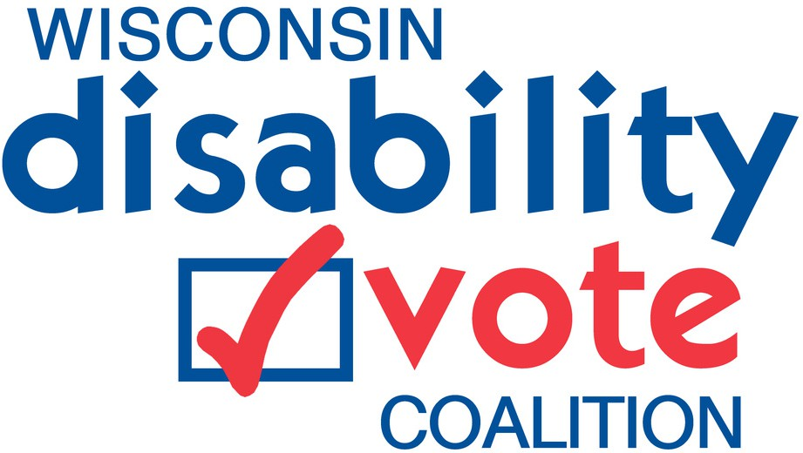


Join Us for a Watch Party!

Your Voice, Your Vote: Understanding Your Rights and Voting Access as a Blind or Low Vision Voter
Helping to give individuals who are blind or visually impaired, the information they need to vote confidently, independently, and accessibly.

Watch Party Dates/Times from 0:00am - 00:00pm

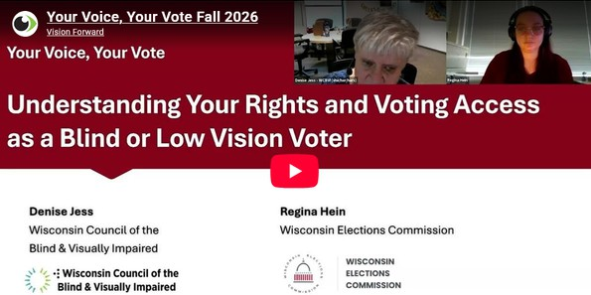

Learn more about...
Wisconsin voter registration
Reasonable accommodations for every step of the process Knowing your rights
Where to go if you need assistance Type of ID and proof of residence

Registration, contact and information if needed xxxxxxxxxxxxxxxxxxxx

